**Assignment No.5**

**GREP commands**

**1. create file emp.txt with following content,**

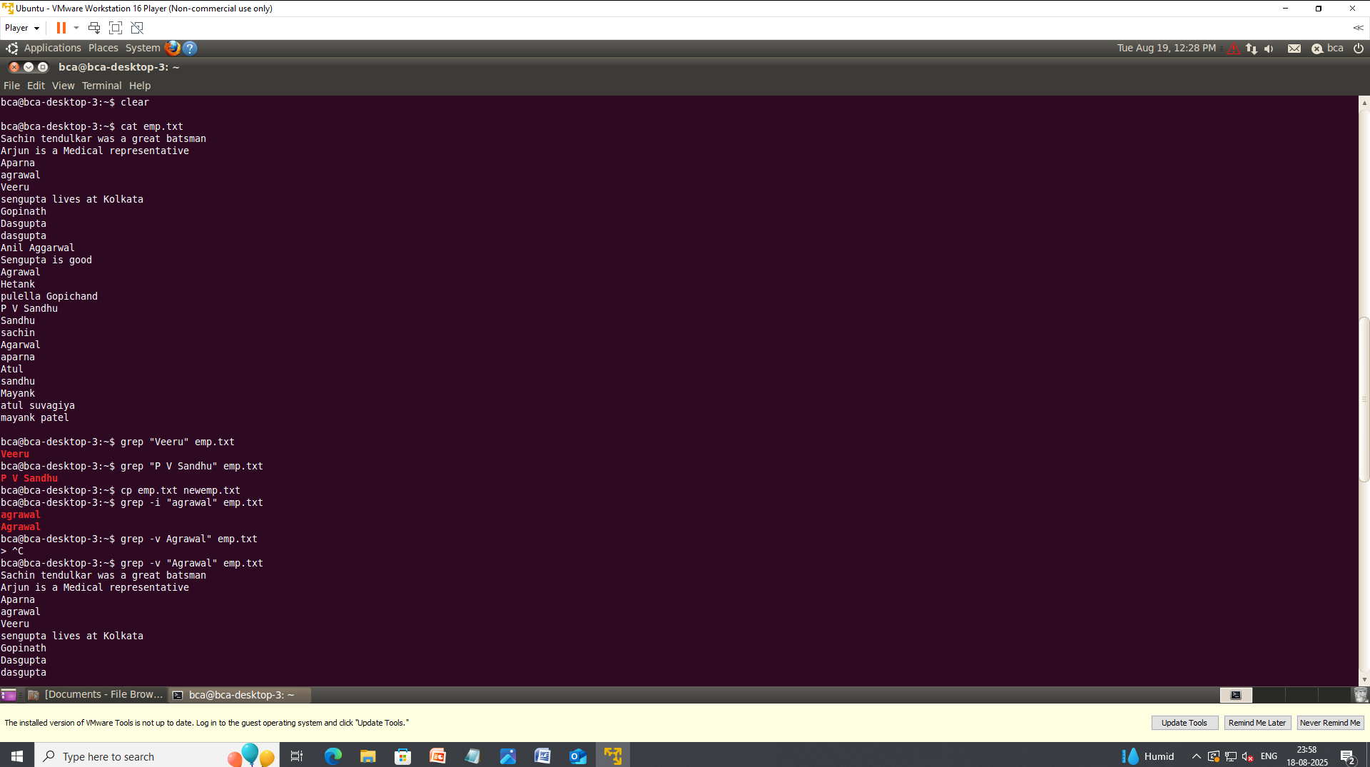

2. Find employee Veeru from emp.txt



3. find pattern P V Sandhu from emp.txt



4. copy file emp.txt and create new file newemp.txt with copied content.



**5. find Atul from file emp.txt and newemp.txt**



6. find Agrawal or agrawal from file.



**7. display all the lines from emp.txt except those containing Agrawal.**

**8. display the line numbers containing pattern agrawal.**

9. count total number of lines containing pattern Sandhu or sandhu.

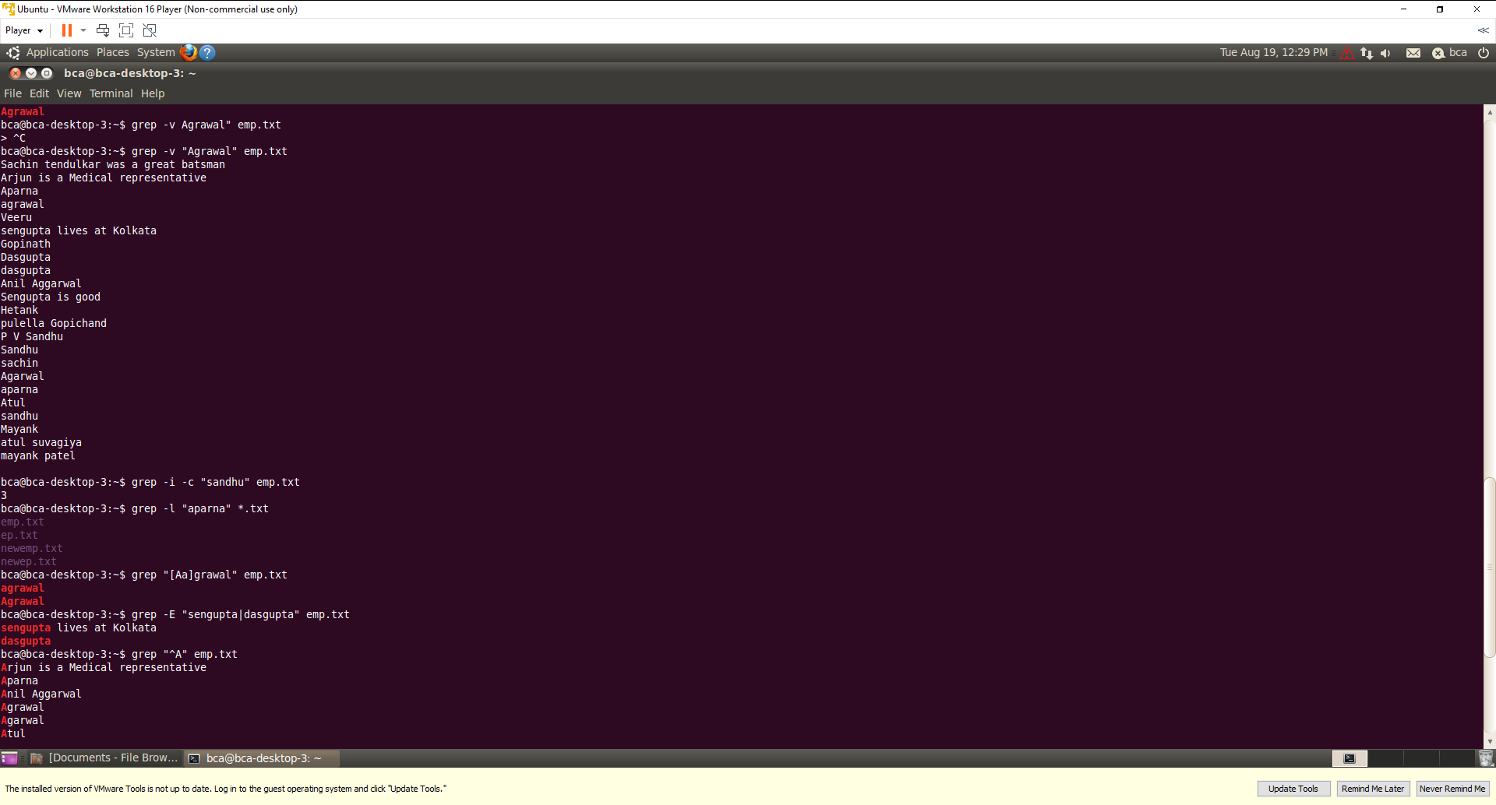

10. display name of text files containing pattern Aparna



11. find agrawal or Agrawal from emp.txt using character class.



12. find multiple pattern sengupta and dasgupta from emp.txt.



13. display lines that starts with character A.



14. display line which end with character k.

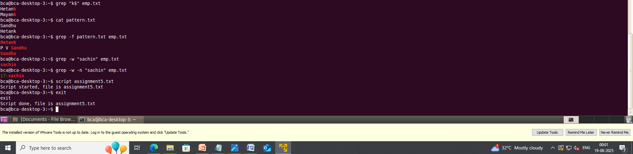

15. create file pattern.txt containing

Sandhu

Hetank



Using file pattern.txt, search the words included in emp.txt.



16. print line/s which only contains sachin word.

